**Reduced structure-function coupling converge to brain hubs and correlates with symptoms of chronic attention-deficit hyperactivity disorder**

Luke J. Hearne1,2§, Hsiang-Yuan Lin3§, James A. Roberts4, Wen-Yih Isaac Tseng5,6, Susan Shur-Fen Gau3,6, Luca Cocchi2

1 Center for Molecular and Behavioral Neuroscience, Rutgers University, Newark, New Jersey.

2 Clinical Brain Networks Group, QIMR Berghofer Medical Research Institute, Brisbane, Queensland, Australia.

3 Department of Psychiatry, National Taiwan University Hospital, and College of Medicine, Taipei, Taiwan.

4 Brain Modelling Group, QIMR Berghofer Medical Research Institute, Brisbane, Queensland, Australia.

5 Institute of Medical Device and Imaging, National Taiwan University College of Medicine, Taipei, Taiwan.

6 Graduate Institute of Brain and Mind Sciences, National Taiwan University College of Medicine, Taipei, Taiwan.

§Shared first authorship

*Corresponding author:

Susan Shur-Fen Gau, …

…

Abbreviated title: Brain network structure-function coupling in ADHD

Number of pages:

Figures:

Tables:

Number of words: X (Abstract), X (Introduction), X(Discussion)

**Abstract**

**Introduction:** Adults with childhood-onset ADHD show altered structural and functional whole-brain connectivity. However, the relationship between structural and functional brain abnormalities in ADHD remain uncharted. This knowledge is important to understand the neural basis of ADHD symptoms and develop targeted interventions.

**Methods:** We recruited78 medication-naive adults with established childhood-onset ADHD without co-occurring psychiatric conditions, and 118 age- sex- and intelligence-matched healthy controls. Structural and functional connectivity matrices were derived from diffusion tensor imaging and resting-state data, respectively. Hub, feeder, and local connections were defined using structural matrices. Individual level measures of structural connectivity and structure-function coupling were used to contrast groups and link behaviour to brain abnormalities.

**Results:** Structural connectivity did not significantly differ between adult ADHD and healthy controls. Relative to controls, adults with ADHD showed reduced structure-function connectivity coupling in feeder connections, linking hubs with peripheral regions. This abnormality involved connections within the control network, as well as linking the control system with default-mode and sensorimotor networks. Crucially, we found that lower structure-function coupling was associated with higher ADHD symptoms.

**Conclusions:** This studycomplements previous investigations of structural and functional whole-brain network abnormalities in adult ADHD, highlighting a distinct breakdown in the healthy function-structure relationship in connections linking hubs with peripheral brain regions. This reduction in the function-structure relationship provides further support for the notion that control and default mode networks abnormalities play a key role in the persistence of ADHD in adulthood.

**Introduction**

Adult attention-deficit hyperactivity disorder (ADHD) is a neurodevelopmental disorder characterised by inattentive and hyperactive-impulsive symptoms beginning in childhood [(Asherson, Buitelaar, Faraone, & Rohde, 2016)](https://www.zotero.org/google-docs/?GTl02J). Despite decades of research, identifying the neural underpinnings of adult ADHD is an ongoing research endeavour. This dearth of knowledge impedes the understanding of mechanisms supporting different clinical outcomes following childhood ADHD, and the consequent development of novel targeted interventions [(Sudre, Mangalmurti, & Shaw, 2018)](https://www.zotero.org/google-docs/?NtIwnk).

Neuroimaging work has provided important insights on altered structural [(Aoki, Cortese, & Castellanos, 2018; L. Chen et al., 2016; van Ewijk, Heslenfeld, Zwiers, Buitelaar, & Oosterlaan, 2012)](https://www.zotero.org/google-docs/?fdTxJc) and functional [(Castellanos & Aoki, 2016)](https://www.zotero.org/google-docs/?0E1IcU) connectivity underpinning ADHD symptoms. Structurally, affected white matter tracts include bundles connecting the bilateral cerebral hemispheres, posterior circuits related to the limbic and occipital systems [(L. Chen et al., 2016)](https://www.zotero.org/google-docs/?uVoZ4A), as well as frontal-striatal-cerebellar and frontoparietal pathways [(Rubia, Alegria, & Brinson, 2014; van Ewijk et al., 2012)](https://www.zotero.org/google-docs/?JKnDxP). Recent work adopting graph analysis have suggested that deficits in white matter connectivity results in reduced global but increased local efficiency in children with ADHD [(Cao et al., 2014)](https://www.zotero.org/google-docs/?ywbqM3), as well as preserved global but altered local properties in adults with ADHD [(Sidlauskaite, Caeyenberghs, Sonuga-Barke, Roeyers, & Wiersema, 2015)](https://www.zotero.org/google-docs/?McIWNk). These findings suggest that the persistence of ADHD symptoms in adulthood rely on specific deficits in whole-brain connectivity.

In line with the structural abnormalities detected by diffusion MRI work, resting-state functional magnetic resonance image (fMRI) studies have highlighted that the diagnosis and symptoms of ADHD are linked to a reduced segregation between the activity of networks supporting external task engagement and the default mode brain network [(Castellanos & Aoki, 2016; Cocchi et al., 2012; H.-Y. Lin et al., 2018)](https://www.zotero.org/google-docs/?Eg4RmU). By adopting multivariate methods to link brain network connectivity and behaviour, our group has recently showed that the severity of adult ADHD symptoms is mediated by the degree of altered functional connectivity between default-mode and control networks [(H.-Y. Lin et al., 2018)](https://www.zotero.org/google-docs/?P1FA5A). Reduced connectivity within the default-mode network, has also been reported both in children and adults with ADHD [(Castellanos & Aoki, 2016; Rubia et al., 2014)](https://www.zotero.org/google-docs/?YdtcCt). Together, these results support the core role of control-default mode systems in ADHD.

Despite the spatial overlap of structural and functional brain networks abnormalities in adult ADHD, the direct relationship between these aberrations remains largely unexplored. Closing this knowledge gap is paramount to isolate key neural factors contributing to the persistence of ADHD symptoms in adulthood. Here, we used state-of-the-art multi-echo resting-state fMRI and diffusion spectrum imaging (DSI) to investigate possible changes in whole-brain function-structure coupling in a large sample of well characterised medication-naïve adults with ADHD and matched healthy controls [(H.-Y. Lin et al., 2018)](https://www.zotero.org/google-docs/?4umW3y). Based on previous findings, in ADHD we expected greater departures from a healthy structure-function association in so-called hub brain connections (Crossley et al, van den Heuval). Moreover, when examined, we expected that connections linking control and default mode brain regions would explain this effect. Finally, we speculated that differences in structure-function coupling would correlate with ADHD symptoms.

**Methods**

*Participants and procedure*

We recruited 80 medication-naïve adults with childhood-onset ADHD aged 18–39 years (mean 26.7 years), who fulfilled full DSM-IV-TR criteria for the current diagnosis of ADHD (>6 symptoms in either inattention, hyperactivity/impulsivity, or both domains). This medication-naïve, carefully phenotyped sample allows the unequivocal assessment of structural and functional brain networks in the absence of common confounding variables including developmental delays and cognitive deficits. Results from the clinical sample were benchmarked against the findings of 123 age (mean 25.7 years), sex, and IQ-matched healthy controls.

Participants were assessed at the adult ADHD special clinic of the Department of Psychiatry, National Taiwan University Hospital (NTUH), Taipei, Taiwan from March 2014 to December 2016. The sample has been previously used to assess the multivariate relationship between ADHD symptoms and functional brain network connectivity [(H.-Y. Lin et al., 2018)](https://www.zotero.org/google-docs/?PH5cQH). Extensive details regarding the recruitment procedure are described in our previous work [(H.-Y. Lin et al., 2018)](https://www.zotero.org/google-docs/?gHbD3i). Briefly, recruitment occurred via advertisements at hospitals, colleges and online. Potential participants were screened using the Chinese version of the Adult ADHD Self-Report Scale (ASRS) v1.1 [(C.-B. Yeh, Gau, Kessler, & Wu, 2008)](https://www.zotero.org/google-docs/?JqNSuG). Individuals deemed eligible to enter the study were invited for a clinical interview conducted by a board-certified child psychiatrist with extensive experience in ADHD (Author S.S.G.). A diagnosis of ADHD resulting from the clinical interview was confirmed by the Conners’ Adult ADHD Diagnostic Interview [(Conners, Erhardt, & Sparrow, 1999)](https://www.zotero.org/google-docs/?AD9Z4G) and the adult version of the ADHD supplement of the Chinese version of the Kiddie-Schedule for Affective Disorders and Schizophrenia-Epidemiological Version for childhood and current ADHD [(Y.-J. Lin, Yang, & Gau, 2016)](https://www.zotero.org/google-docs/?S7kzDw). Matched healthy controls were recruited using the same procedure adopted for the ADHD group. For both ADHD and controls the following exclusion criteria were adopted: medical illness other than ADHD, substance abuse, past or current use of psychotropic medication, cognitive deficits (<80 full-scale IQ measured by the Wechsler Adult Intellectual Scale-Third Edition [(Tulsky, Saklofske, Wilkins, & Weiss, 2001)](https://www.zotero.org/google-docs/?784lKd)). The study was approved by the Research Ethics Committee of the NTUH (201401024RINC) and registered as a clinical trial (NCT02642068). Written informed consent was obtained for all participants.

*Imaging acquisition*

Brain imaging data were acquired with a Siemens 3 T Tim Trio scanner equipped with a 32-channel head coil located at the NTUH. The imaging protocol included: localizer, resting state fMRI (7 min and 39 seconds), T1-weighted, and DSI. Functional images implicate multi-echo EPI sequence: TR = 2.55 s; flip angle = 90°; matrix size = 64 × 64; in-plane resolution = 3.75 mm; FOV = 240 mm; 31 oblique slices, alternating slice acquisition slice thickness 3.75 mm with 10% gap; iPAT factor = 3; band- width = 1698 Hz/pixel; echo time, TE = 12, 28, 44 and 60 msec). T1 image applied MPRAGE sequence with a TR = 2 s; TE = 2.98 msec; flip angle = 9°; matrix size = 256 × 256; inversion time = 900 msec; voxel size = 1 mm3. DSI used pulsed-gradient spin-echo diffusion echo planar imaging sequence with a twice-refocused balanced echo repetition time/echo time = 9600/130 msec, slice thickness = 2.5 mm, acquisition matrix = 80 × 80, field of view = 200 × 200 mm, in-plane spatial resolution = 2.5 mm × 2.5 mm, 101 diffusion-encoding directions covering a half q-space 3D grid with radial grid size of 3, bmax= 4000 s/mm2 [(Wedeen, Hagmann, Tseng, Reese, & Weisskoff, 2005)](https://www.zotero.org/google-docs/?KJqfqI)

*MRI Preprocessing*

Details regarding the preprocessing of the multi-echo resting-state data are described comprehensively elsewhere [(H.-Y. Lin et al., 2018)](https://www.zotero.org/google-docs/?uXGgOe). In short, the pipeline included: comprehensive data denoising using multi-echo independent components analysis [(ME-ICA v3.0 beta1, Kundu, Inati, Evans, Luh, & Bandettini, 2012; Parkes, Fulcher, Yücel, & Fornito, 2018)](https://www.zotero.org/google-docs/?2LHs5r), coregistration to individual anatomical images, non-linear normalization to MNI space, and filtering (0.01∼0.1 Hz). Micro-head movements were not significantly different between ADHD and controls (*p* = .23).

The DSI data underwent an initial quality assurance procedure: Individual DSI images [54 slices × (101 directions DW images + 1 null image) = 5,508 images] were scrutinized by calculating signals in the central square (20 × 20 pixels) of each image. Signal loss was defined as the average signal intensity of an image lower than two standard deviations from the mean of all images (after correcting for its b value) [(Y.-J. Chen et al., 2015)](https://www.zotero.org/google-docs/?1Lf1zB). As jerky head motion induces signal loss in DSI images, these signal dropout counts were considered a proxy estimate for overall levels of in-scanner head motions. Individuals of DSI data with more than 90 images of signal loss, at either baseline or follow-up, were excluded from further analyses [(Y.-J. Chen et al., 2015)](https://www.zotero.org/google-docs/?fGVnvm), resulting in a final sample of 78 adults with ADHD and 118 healthy controls (**Table 1**).

**Table 1. Demographic and clinical features of the participants.**

|  |  |  |  |
| --- | --- | --- | --- |
| Mean (SD) | **Control (N=118)** | **ADHD (N=78)** | **Statistics** |
| **Age (18-39 years)** | 25.8 (5.0) | 26.6 (5.5) | *p* = 0.287 |
| **Sex (M/F)** | 76/42 | 54/24 | *p* = 0.484 |
| **Handedness (R/L)** | 113/5 | 64/14 | *p* = 0.001 |
| **FIQ** | 109.8 (9.3)  (range: 89-138) | 107.5 (10.4)  (range: 80-137) | *p* = 0.101 |
| **VIQ** | 108.2 (9.0) | 105.7 (11.2) | *p* = 0.088 |
| **PIQ** | 110.4 (11.4) | 108.3 (16.3) | *p* = 0.289 |
| ***ADHD symptoms*** |  |  |  |
| **Inattention**a | 6.6 (4.9) | 19.6 (5.0) | *p* < 0.001 |
| **Hyperactivity/Impulsivity**a | 3.2 (4.4) | 13.4 (6.4) | *p* < 0.001 |
| **ASRS-A** | 13.3 (5.2) | 27.0 (4.8) | *p* < 0.001 |
| **ASRS-B** | 9.1 (5.2) | 19.9 (6.3) | *p* < 0.001 |
| **Mean frame-wise displacement**b **(mm)** | 0.045 (0.021)  (range: 0.014-0.123) | 0.048 (0.024)  (range: 0.017-0.108) | *p* = 0.354 |
| **Signal dropout counts**c | 30.8 (22.4) | 28.8 (21.4) | *p* = 0.536 |

a Measured by the parent-rated Swanson, Nolan, and Pelham, version IV (SNAP-IV) scale.

b Estimated by the Euclidian norm (enorm: square root of the sum of squares of the differences in motion derivatives), computed with AFNI's 1d_tool.py.

c A summary estimate of in-scanner motion levels (see the Methods).

Abbreviation: ADHD=attention-deficit hyperactivity disorder; FIQ=full intelligence quotient; PIQ=performance intelligence quotient; VIQ=verbal intelligence quotient; ASRS=Adult ADHD Self-Report Scale; M=male; F=female; R=right; L=left; SD=standard deviation.

DSI data were reconstructed using the *q*-space diffeomorphic reconstruction (QSDR) approach implemented in DSI Studio ([www.dsi-studio.labsolver.org](http://www.dsi-studio.labsolver.org/)) [(F.-C. Yeh, Wedeen, & Tseng, 2011)](https://www.zotero.org/google-docs/?dTbMYr). QSDR first computed the quantitative anisotropy in each voxel in native space. Then the reconstructed images were warped to a template in Montreal Neurological Institute (MNI) space using constrained diffeomorphic mapping. In MNI space, a diffusion sampling length ratio of 1.25 mm with five fiber orientation per voxel and 8-fold orientation distribution function tessellation (642 sampling directions) was used to obtain the spin distribution function, and the output resolution was 2 mm. A deterministic fiber tracking algorithm [(F.-C. Yeh, Verstynen, Wang, Fernández-Miranda, & Tseng, 2013)](https://www.zotero.org/google-docs/?GFOyMM) was performed with extreme turning angle threshold of 60°, step size of 1.0 mm, minimum and maximum length of 10  and 400 mm, respectively. 10,000,000 streamlines were seeded throughout the whole brain and terminated when the local quantitative anisotropy fell below values estimated using Otsu's threshold [(F.-C. Yeh et al., 2013)](https://www.zotero.org/google-docs/?uB4EYM), which gives the optimal separation between background and foreground. Other tracking parameters as specified in DSI Studio were: smoothing: 0; seed orientation: all; seed position: subvoxel; randomize seeding: off; direction interpolation: trilinear.

*Functional and structural network construction*

We generated whole-brain structural and functional connectivity matrices for each participant, based on a common and recently validated cortical parcellation [(Schaefer et al., 2018; **Figure 1A**)](https://www.zotero.org/google-docs/?Y7bhDz). Fourteen additional subcortical structures from the Harvard-oxford atlas (<https://fsl.fmrib.ox.ac.uk/fsl/fslwiki/Atlases)> including the thalamus and the striatum were added to the parcellation, resulting in 214 total regions (represented as *Schaefer-214* in the following text; **Supplementary Table 1**).

Individual whole-brain tractography maps (see above) were combined with the pre-defined anatomical boundaries defined by the parcellation [(Schaefer et al., 2018)](https://www.zotero.org/google-docs/?ou0SAC) to generate a weighted structural network (a 214 × 214 weighted structural connectivity matrix; **Figure 1B**). Each edge of the network corresponds to the total number of normalized streamlines that interconnect two brain regions, adjusted for the interregional fibre length (cite).

For resting-state data, mean regional time-series were calculated for each region included in the brain parcellation. The statistical association between the time-series of all regions was estimated using Person’s correlation, resulting in a 214 x 214 connectivity matrix for each individual. A Fisher z-transformation was applied to each functional connectivity matrix.

*Connection classes: hub, feeder and local connections*

Varying definitions of brain network hubs exist [(Sporns, Honey, & Kötter, 2007)](https://www.zotero.org/google-docs/?K3hC3l). Here, we identified hub-regions according to aggregate ranking across multiple metrics [(Betzel et al., 2014; Perry et al., 2015)](https://www.zotero.org/google-docs/?1kgR4g). First, for each participant, each node's “hubness” was calculated from its composite average ranking across degree, strength, betweenness and subgraph centrality scores using the brain connectivity toolbox (Rubinov and Sporns, 2010). The top 15% composite scores (N = 32, **Supplementary Table 1&2**) were used to identify hub-regions within each participant, all other nodes were assigned as *periphery* nodes. Hub *connections* were defined as edges that connected any two hub nodes. Feeder connections linked hub-nodes to periphery nodes, and local connections linked periphery nodes [(van den Heuvel, Kahn, Goñi, & Sporns, 2012; van den Heuvel et al., 2013; **Figure 1C**)](https://www.zotero.org/google-docs/?7iSXZi).

*Structure-function relationships*

Brain network structure-function relationships were conducted in line with previous research involving a case-control experimental design [(van den Heuvel et al., 2013)](https://www.zotero.org/google-docs/?Ghcblt). First, non-zero structural connectivity values within each individual connectome were isolated and normalized using a rank-based inverse gaussian transformation (Van der Waerden BL, 1952). The resulting structural connectivity values were correlated with corresponding functional connectivity values (i.e., the same edges), within each individual. This analysis produced a single Pearson’s *r* value that summarised the structure-function association for each individual [(Honey et al., 2009; van den Heuvel et al., 2013)](https://www.zotero.org/google-docs/?Qvh8Qp). These values were used to populate group distributions (healthy control versus ADHD), and were subsequently contrasted using between-groups statistics. This entire procedure was completed at the level of the whole network and within each respective connection class: hubs, feeders, and local edges. These analyses tested the hypothesis that function-structure abnormalities in ADHD involve connections linked to hub regions.

Previous work investigating resting-state networks, including data from the current cohort (Lin et al., 2018), has highlighted the role of control, default-mode and sensory networks in ADHD (Castellanos et al… Cocchi et al… 2012). Based on these results, and the general notion that ADHD is characterised by deficits in behaviour associated with these networks, we tested for specific changes in structure-function coupling within control, sensory and default-mode networks. Region-wise network affiliations were combined to ensure that enough edges were included in each analysis to conduct a robust structure-function correlation (defined here as at least 50 data in each vector). Thus, control networks were defined as the combination of fronto-parietal, attention and cingulo-opercular affiliations from the adopted parcellation, while sensory connections included both visual and sensory-motor affiliations. Default-mode connections were as in the original parcellation. Once structure-function coupling was estimated within each network, the mean *r* values (Control - ADHD) were presented within and between each network as a qualitative analysis.

*Relationship between structure-function coupling and behavioural symptoms of ADHD*

Given the notion that measures of ADHD symptoms are continuously distributed in the general population [(Coghill & Sonuga-Barke, 2012; Demontis et al., 2018)](https://www.zotero.org/google-docs/?zX3Km5), we implemented the analysis of brain-behavior relationships across both ADHD and control groups (**Figure 1D**). This approach leveraged the large total sample size, increasing statistical power. Inattention and hyperactivity/impulsivity symptoms based on the self-rated ASRS [(C.-B. Yeh et al., 2008)](https://www.zotero.org/google-docs/?HdLpb6) and parent-reported SNAP-IV [(Gau et al., 2008)](https://www.zotero.org/google-docs/?krs7ud) (**Table 1**) were considered in the analysis. These four symptom items were transformed using a rank-based inverse gaussian, then entered into a principle component analysis to reduce the dimensionality of the data and establish a single summary measure. The first component, accounting for 80.72% of the variance, was then correlated with structure-function coupling (**Supplementary Table 3**). One participant without behavioural data was excluded from this analysis (N = 195). Pearson’s correlation was used to assess the brain-symptom relationship, given the behavioural data was already transformed to a gaussian distribution.

*Statistical comparisons across groups*

To ensure that differences in the overall density of structural network did not explain between-group changes, summed binary and summed weighted degree were compared between groups. Average connection weight within each *connection class* (hubs, feeder and local) were compared between each group. In addition, the network based statistic [(Zalesky, Fornito, & Bullmore, 2010)](https://www.zotero.org/google-docs/?HN1QS1) was used to explore any possible differences in structural connectivity (not limited to connection classes) between the control and ADHD group (5000 permutations). As ADHD associated alterations of functional connectivity using the network based statistic in the same sample have been reported elsewhere [(H.-Y. Lin et al., 2018)](https://www.zotero.org/google-docs/?3kWOnb), herein we intentionally did not implement this analysis for the functional connectivity.

Non-parametric Wilcoxon rank-sum tests were used to identify possible differences in the function-structure association between control and ADHD groups. Bonferroni correction for multiple comparisons was applied to follow-up statistics (noted in text). Statistical significance was declared when the corrected alpha error was less than 5%. To quantify effect sizes, z-values are reported.

*Control analyses*

A number of tests were conducted to establish the reliability of our findings. To ensure that our chosen brain parcellation had little bearing on the results (Zalesky et al., 2010) we successfully replicated the analysis in two distinct brain parcellations of differing resolutions (213 and 244 regions) developed with independent methods [(Fan et al., 2016; Shen, Tokoglu, Papademetris, & Constable, 2013)](https://www.zotero.org/google-docs/?yydBU5) (**Supplementary Table 4**). Details regarding these results are presented in Supplementary **Table 5&6**. To confirm that our definition of hubs did not bias the results we successfully replicated the results at two other thresholds (12.5% and 17.5%, see **Supplementary Table 7**). Furthermore, we note that repeating the structure-function coupling analysis with no structural connectivity data transform had no effect on the results. Finally, to check that the brain-behaviour correlation was not driven by a single variable captured in the PCA, each behavioural variable was correlated independently with structure-function coupling (**Supplementary Table 8**).

Statistical analyses were performed in MATLAB (Mathworks) the code used to generate the results is available via github (<https://github.com/ljhearne/ADHDSCFC>).

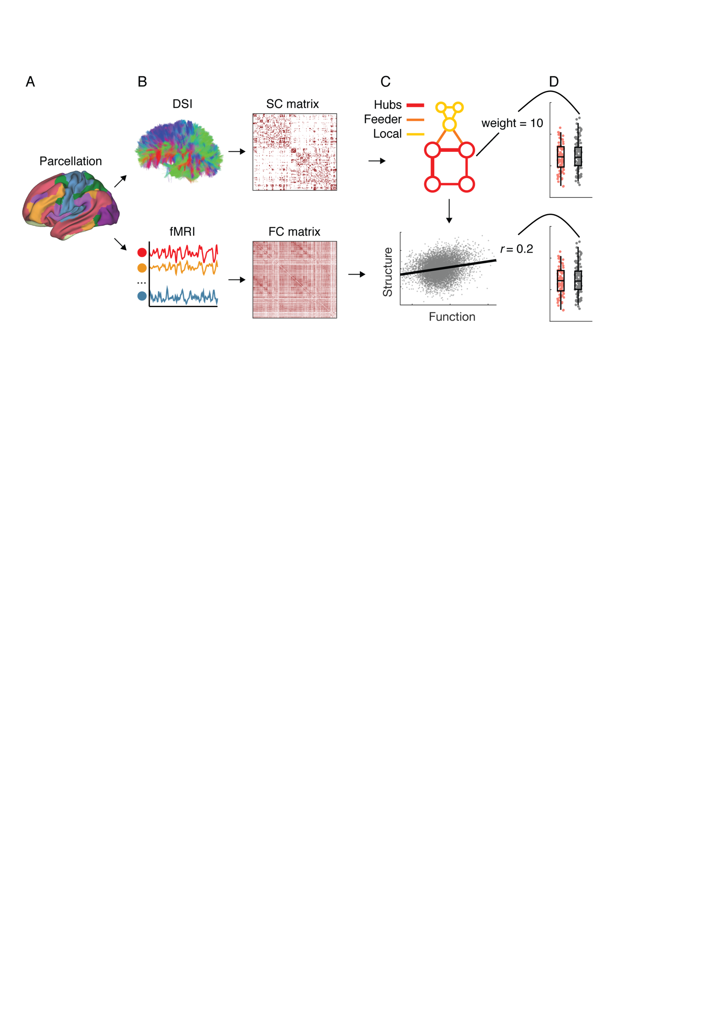

**Figure 1. Conceptual overview of analysis pipeline. A.** Analyses were conducted using a whole brain parcellation including 214 cortical and subcortical regions. Replication analyses were performed using two alternative brain parcellations (see text). **B.** Structural and functional connectivity matrices were derived from diffusion tensor imaging (DSI) and multi-echo resting-state fMRI data, respectively. In such matrices darker colours indicate higher normalized streamline counts (structural connectivity) and higher fisher-z normalized Pearson’s correlation values (functional connectivity) between every possible pair of brain regions. **C.** The topological organisation of the structural matrices was examined to derive measures of different connection types: hub connections, feeder connections, and local connections. Crucially, the putative association between structural and functional connectivity was assessed at individual level. **D.** Individual level measures of structural connectivity (top) and structure-function coupling (bottom) were used to build group-level distributions that were contrasted using non-parametric statistics.

**Results**

*Structural connectivity*

We began by testing for possible differences in structural connectivity between healthy control and medication-naive ADHD groups. Wilcoxon rank-sum tests revealed no difference in weighted (*p* = .89, *z* = 0.13), or unweighted (*p* = .24, *z* = -1.19) summed degree across groups. Likewise, whole-brain network-based statistic comparing ADHD and healthy control groups revealed no significant differences.

Next, we sought to investigate potential differences in *classes* of structural connections, namely hubs, feeders, and local connections (van den Heuval et al., 2012). Wilcoxon rank-sum tests revealed no significant difference between ADHD and healthy controls when comparing mean connection strength within hub (*p* = .86, *z* = -0.17), feeder (*p* = .77, *z* = -0.29), or local connections (*p* = .23, *z* = 1.21). Collectively, these results demonstrated comprehensive non-significant differences between ADHD and control groups in the structural connectome (**Figure 2**).

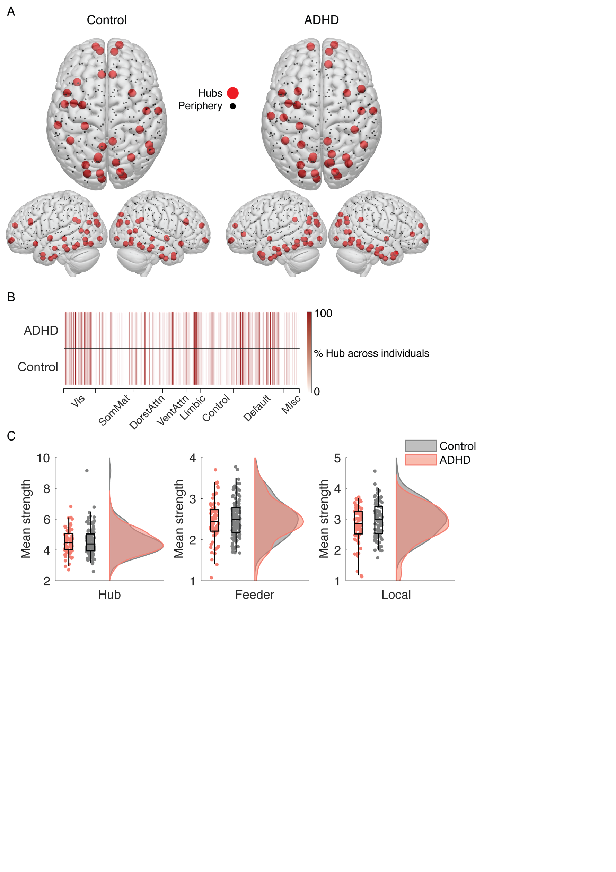

**Figure 2.** *Structural hub topology in adult ADHD and healthy matched controls.* **A.** Brain rendering of group average hub (red) and periphery (black) nodes. **B.** Individual-level representation of hub regions in canonical resting-state brain networks. Darker lines indicate more consistency within each group (i.e., dark red represents every individual had a hub node within the ADHD or Control group). Overall, this plot highlights the consistency in detecting hub regions at the level of single subjects between groups. **C.** Distributions of the average strength of hub, feeder and local connections visualized with ‘raincloud’ plots (Allen et al., 2018). All three results strongly suggest that there are minimal differences in structural hubs between the two groups regarding both spatial distribution and connection strength. Healthy controls are shown in grey and the ADHD group is shown in orange. There were no statistical significant differences at *p* < .05. Abbreviation: Vis=visual; SomMat=sensorisomatomotor; DorstAttn=dorsal attention; VentAttn=salience/ventral attention; Limbic=affective; Control=frontoparietal; Default=default-mode; Misc=miscellaneous (subcortical).

*Coupling between structural and functional connectivity*

When considering all edges within the network, results indicated a significant difference in structure-function coupling (*p* = .01, *z* = 2.51, **Figure 4A**). We then assessed the contribution of each connection class type (hub, feeder or local). Results showed that compared to controls, ADHD had a lower function-structure association in feeder connections (*pbonf* = .005, *z* = 3.10) but not in hub (*pbonf ~*= 1, *z* = 0.55) or local (*pbonf* = .33 *z* = 1.60) connections (**Figure 4B**).

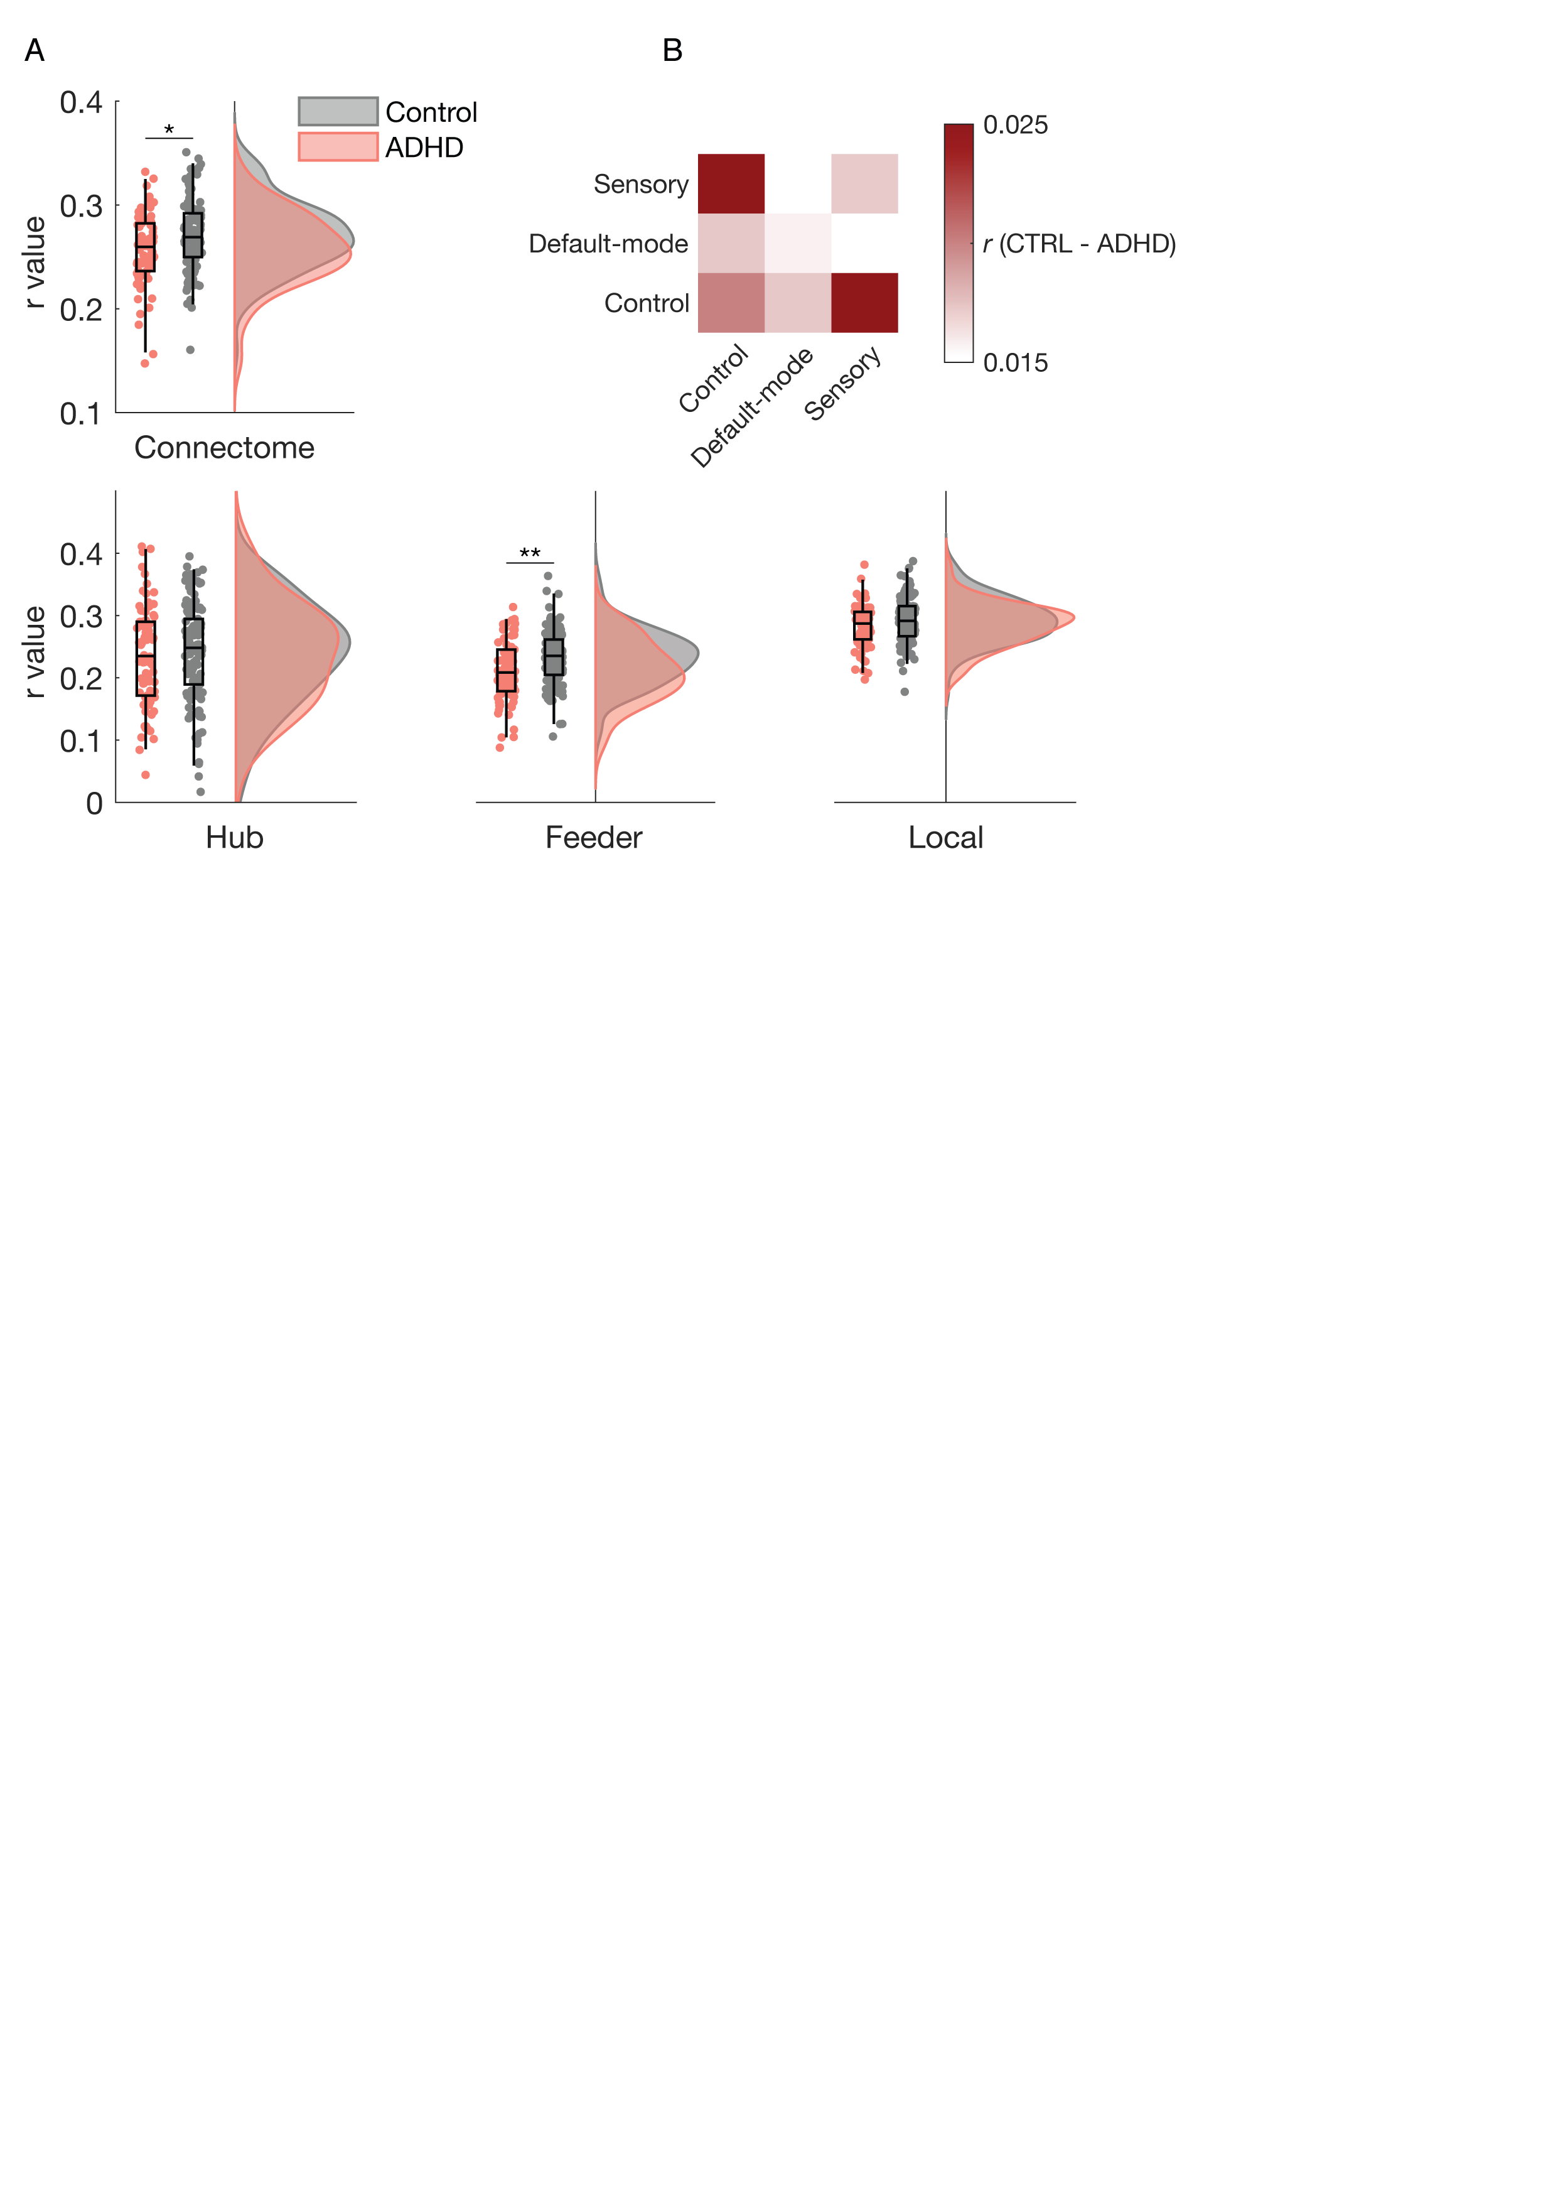

**Figure 4.** *Structure-function relationships in adult ADHD and healthy matched controls.* **A.** Distributions of *r* values across the whole connectome (top) and the three connection classes (bottom). Healthy controls are shown in grey and the ADHD group is shown in orange. Significant differences were observed in the whole connectome but were likely driven by feeder connections. **B.** Mean difference in SC-FC coupling when constrained to feeder connections within and between control, default-mode and sensory functional networks. The largest differences (shown in darker red colours) were found within and between control network connections. * < .05, ** < .01 corrected for multiple comparisons.

*Functional network specificity of Feeder structure-function coupling differences*

To explore the putative breakdown in the structure-function coupling within resting-state networks associated with ADHD (REFS), we isolated feeder connections that belonged to control (an agglomeration of frontoparietal, salience, dorsal attention networks), default-mode, or sensory (merging somatomotor and visual) networks. Network affiliations were merged to ensure enough data were included within each structure-function coupling estimate. Having isolated specific networks, as in the previous analysis, we correlated structural and functional connectivity values within and between these groups of connections. This resulted in a three by three matrix for both ADHD and healthy control groups that represented the degree of structure-function coupling within and between control, default mode and sensory networks. To avoid statistical “double-dipping” [(Kriegeskorte, Simmons, Bellgowan, & Baker, 2009)](https://www.zotero.org/google-docs/?UHNDjM), we present the subtraction of coupling within the Control and ADHD groups (**Figure 4B**). The largest differences were located within control networks and between the control network and default-mode or sensory networks.

*Relationship between indices of structure-function relationship and ADHD symptoms*

Our final analysis investigated the possible relationship between the above structure-function coupling and ADHD symptoms. To reduce the dimensionality of the behavioural measures we conducted a PCA revealing a single component accounting for 80.71% of the variance which all four behaviours loaded onto (see **Supplementary Table 4**). We found that individual symptom scores captured by PCA significantly correlated with indices of structure-function coupling in feeder connections (*p* = .0004, *r* = -0.25, see **Figure 5**). Specifically, we found that lower structure-function coupling was associated with higher ADHD symptoms.

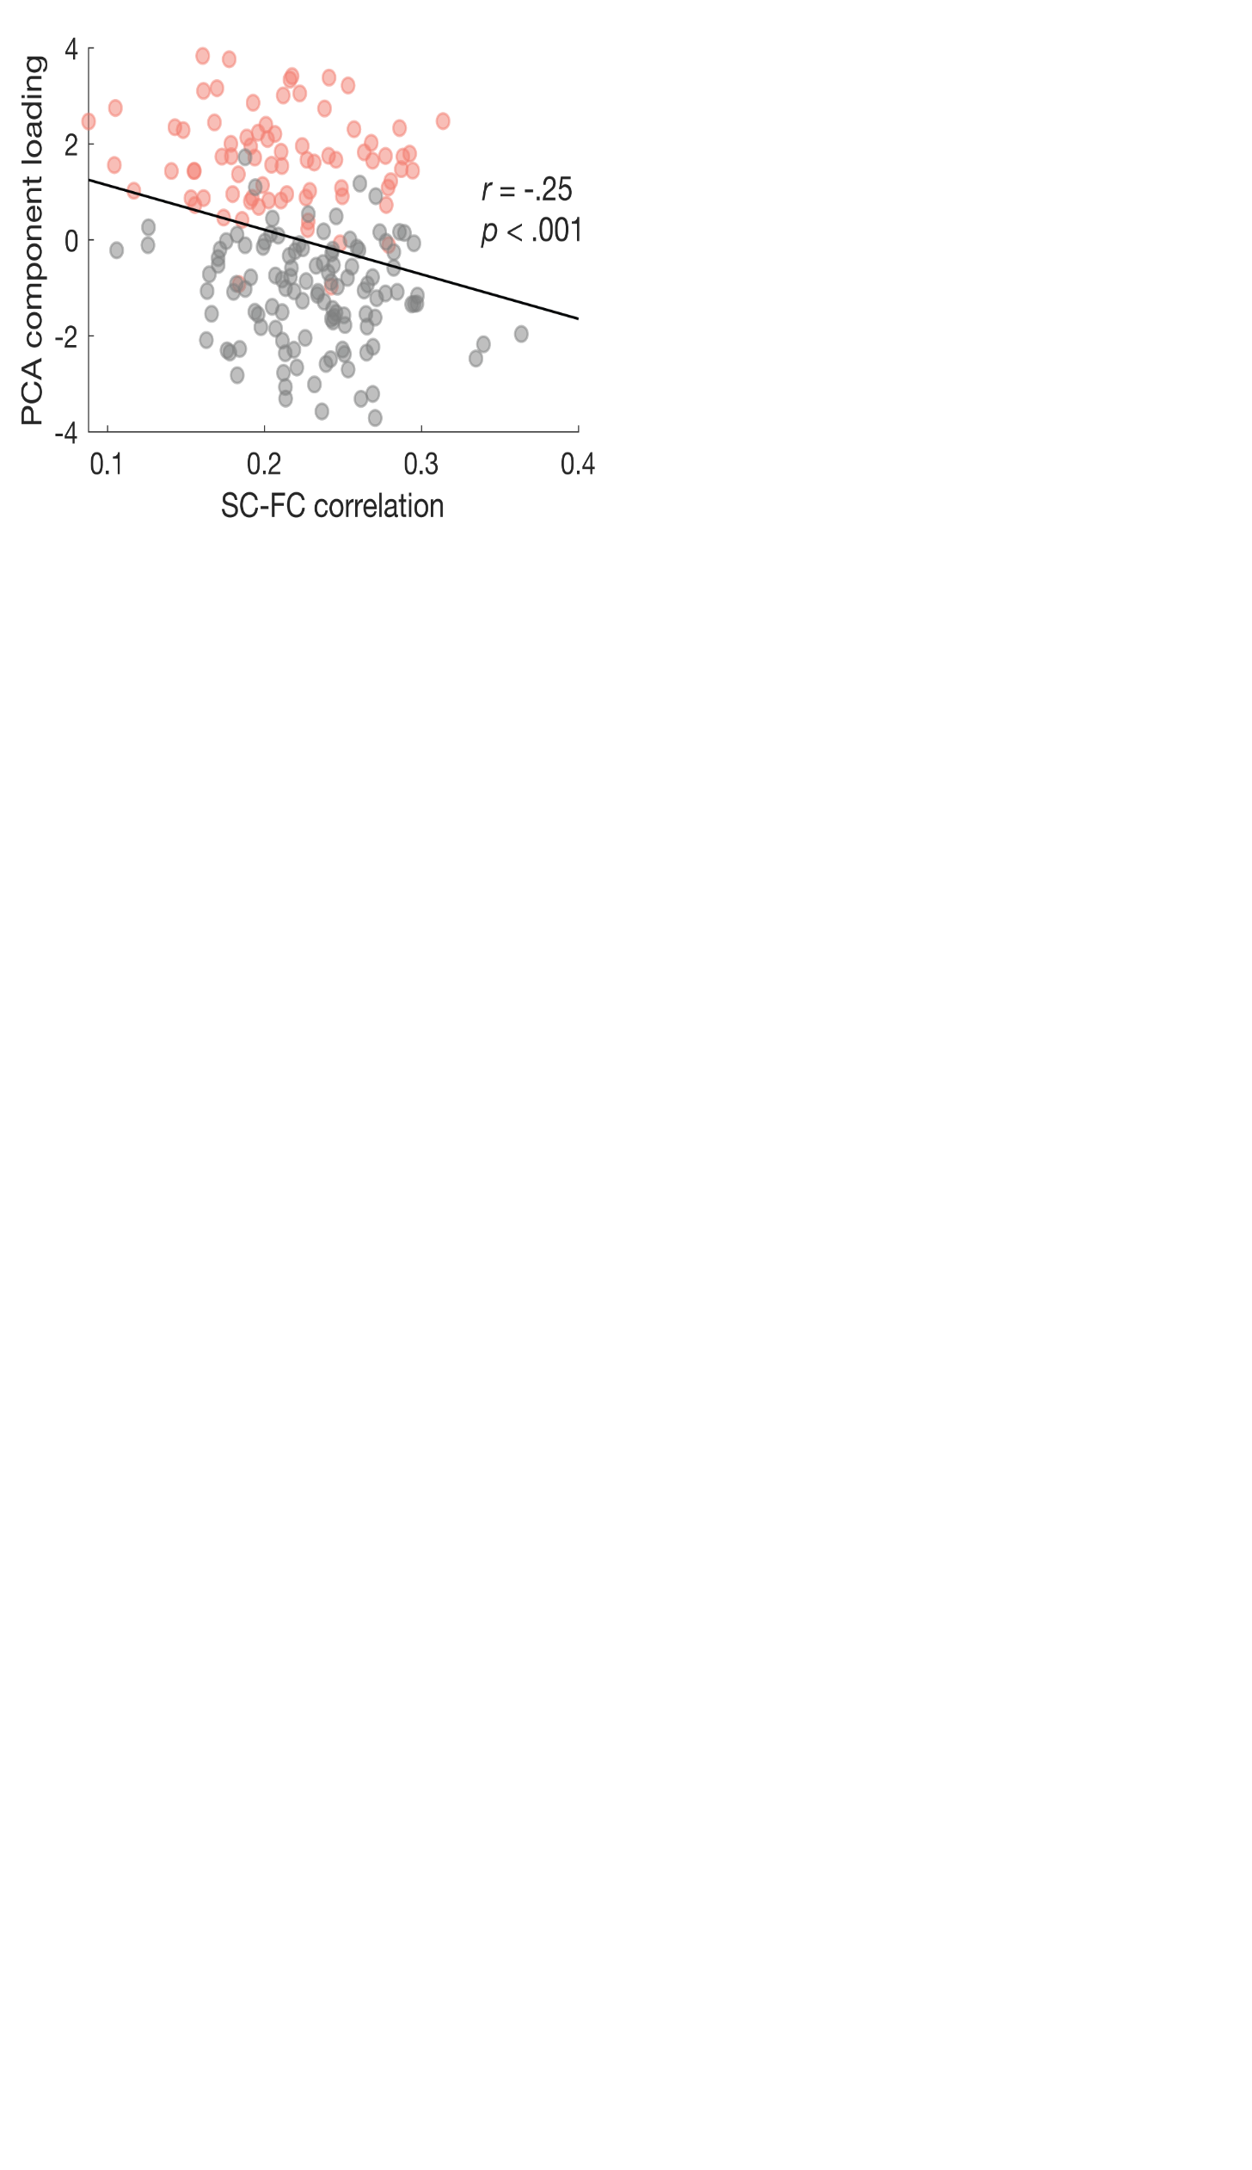

**Figure 5.** *Correlation between symptom and structural-functional connectivity (SC-FC) coupling in feeder connections.* SC-FC coupling strength was negatively correlated with the ADHD symptom factor scores derived from the PCA. That is, higher levels of structure-function decoupling were associated with more severe ADHD symptoms. Red dots denote ADHD individuals; gray dots represent matched healthy control participants.

*Control analyses*

We replicated all results using two other, independent brain parcellations (*Shen-213* and *Brainnetome-244,* see **Supplementary Table 2**). However, using these two alternative brain parcellations, adults with ADHD further exhibited weaker structure-function coupling in hub connections. While significant, the effect size of these between group differences was consistently smaller compared to that in the feeder comparison. The weaker structure-function coupling was not observed using our original parcellation and therefore less robust compared to the reported difference in feeder connections.

ADHD-related reduction in structure-function coupling in the whole connectome and feeder connections was also observed when different thresholds (12.5% and 17.5%) were used to define hubness based on the main parcellation (*Schaeffer-214*) (**Supplementary Table 3**).

The negative correlation between structural-functional coupling and ADHD symptoms was also replicated in the additional brain parcellations (**Supplementary Table 2**). Moreover, to ensure the correlation wasn’t driven by a specific behavioural measure, we demonstrated correlations using the individual scores of self- and parent-rated symptoms (**Supplementary Table 5**).

**Discussion**

The present study provides direct evidence of major deficits in brain structure-function coupling within medication-naive adults with childhood-onset ADHD. Critically, we found that a breakdown in the association between structural and functional connectivity correlated with higher symptoms of ADHD. In line with the hypothesis that hubs regions are vulnerable to brain pathology (refs), ADHD showed a key deficit in connections linking hubs and periphery brain regions within and between control brain networks. This finding confirms the core role of these whole-brain networks in supporting the chronic manifestation of ADHD symptoms.

Structural networks are thought to place strong constraints on functional connectivity and local brain activity [(Deco et al., 2011; Deco & Kringelbach, 2014; Hermundstad et al., 2013; Honey et al., 2009)](https://www.zotero.org/google-docs/?OtHx4X). The decoupling between functional connectivity and it structural basis is therefore thought to represent a key index of brain network pathology in psychiatric illnesses including schizophrenia [(Cocchi et al., 2014; Skudlarski et al., 2010; van den Heuvel et al., 2013)](https://www.zotero.org/google-docs/?cxVwqy). Our results directly support this general notion by showing that the structure-function breakdown in ADHD converges to anatomically defined hub regions. Specifically, we found that feeder connections were the most affected. These connections comprise long anatomical routes allowing efficient communication between distant regions comprising different brain modules [(Perry et al., 2015; van den Heuvel et al., 2012)](https://www.zotero.org/google-docs/?YTRKxk).

Notably, we identified that feeder connections linking within control systems, between control and default-mode, as well as between control and sensory networks, predominantly contributed to reduced structure-function coupling in ADHD. Such findings are consistent with previous resting-state fMRI literature which highlights the potential involvement of these systems and their interactions in the pathophysiology of ADHD [(Cary et al., 2017; Castellanos & Aoki, 2016; Cocchi et al., 2012; H.-Y. Lin et al., 2018; H.-Y. Lin, Tseng, Lai, Matsuo, & Gau, 2015)](https://www.zotero.org/google-docs/?fkqbVl). Moreover, prior work also suggests that dynamics between the these systems are critical in facilitating the normal functions of selective [(Regev et al., 2018)](https://www.zotero.org/google-docs/?gAevJN) and sustained [(Weissman et al., 2006)](https://www.zotero.org/google-docs/?7uldkm) attention. We also observed a correlation with behaviour such that reduced structure-function coupling was associated with higher ADHD symptomology. Taken together, we speculate that the reduced structure–function coupling may be indicative of more unrestrained dynamic brain function from the underlying structural scaffolding, which results in suboptimal modulation of interplay between the control, default-mode, and sensorimotor networks in adults with ADHD. This inefficiency may lead to the observed cognitive and behavioral deficits such as inattention.

The finding of the dissociation between structural and functional connectivity in ADHD is indirectly in line with previous work using similar methodology (diffusion imaging and resting-state fMRI). Bos and colleagues [(Bos et al., 2017)](https://www.zotero.org/google-docs/?fk7k0C) showed that changes in functional connectivity were not accompanied by changes in the underlying white matter structures in ADHD children. Similarly, we also did not observe significant between-group differences in structural connectivity. Some explanations may account for this inconsistency with other prior studies [(Aoki et al., 2018; L. Chen et al., 2016)](https://www.zotero.org/google-docs/?qDSURa). The methods applied herein (the basic topological properties of connectome and network-based statistic) are distinct from previously used tract-based statistics. ADHD-associated alterations in white matter microstructures may be of non-specific properties [(Liston, Malter Cohen, Teslovich, Levenson, & Casey, 2011)](https://www.zotero.org/google-docs/?t0WSfS), and their effect sizes may be too small to survive multiple comparison testing. In addition, the present null finding may reflect our emphasis on comparable levels of head motion between ADHD and controls, as emerging evidence has indicated that in-scanner motion tends to produce spurious group differences [(Yendiki, Koldewyn, Kakunoori, Kanwisher, & Fischl, 2014)](https://www.zotero.org/google-docs/?PTZYpt). Accordingly, a recent meta-analysis highlighted that studies with no differences in head motion between groups tended to report null findings in diffusion imaging measures associated with ADHD [(Aoki et al., 2018, 2017)](https://www.zotero.org/google-docs/?QTSXzf). Our distinct cohort with medication-naive adults having established childhood-onset ADHD in the absence of co-occurring psychiatric conditions may also partly contribute to this negative finding, as psychostimulant exposure [(de Luis-García et al., 2015)](https://www.zotero.org/google-docs/?CB0atI) and comorbidity [(Adisetiyo et al., 2014)](https://www.zotero.org/google-docs/?nVSs2v) have been reported to affect diffusion findings in ADHD. Our findings highlight that future investigations should comprehensively consider confounding factors contributing to heterogeneity in the ADHD literature. Simultaneously, despite no between-group differences in structural connectivity alone, our exploration of structure-function coupling shed new light on the role of structural networks and their correspondence with the functional brain connectivity in ADHD.

Our findings should be interpreted considering some other limitations and caveats. First, while the high resolution (101 diffusion directions), advanced acquisition and reconstruction methods of DSI allow for better capacity to address the crossing fibers issue [(Le Bihan & Johansen-Berg, 2012)](https://www.zotero.org/google-docs/?4xA58Q), deterministic fiber tractography is limited by the ambiguous reliability of the reconstructed tracts [(Maier-Hein et al., 2017)](https://www.zotero.org/google-docs/?TP6La5). The development of novel tractography methods and using probabilistic algorithms - which takes direction-uncertainty into account but is hitherto unavailable for DSI - would complement the current findings in future. Second, we implemented multi-echo acquisitions to better denoise resting-state fMRI data involving a trade-off between levels of spatial and temporal resolution [(Kundu et al., 2012)](https://www.zotero.org/google-docs/?husg7t). Third, although the sex distribution was not different between the ADHD and control groups, and the sex ratio of the current ADHD sample was typical (Asherson *et al.*, 2016), most participants are male. Hence, the present findings may not generalize to female predominant cohorts. Fourth, our participants exhibited higher levels of inattention than hyperactivity-impulsivity problems. Although this clinical profile reflects the typical presentation of adult ADHD, it limits the inference of relations between structure-function dissociation and inhibitory and cognitive control. Lastly, the objective of this study was based on the presumption that the anatomical brain architectures mediates functional interactions between different regions, which support cognitive function. However, with the accumulating data from human patients in the absence of corpus callosum [(Hearne et al., 2018; Tyszka, Kennedy, Adolphs, & Paul, 2011)](https://www.zotero.org/google-docs/?FkrmsB), a caveat should be borne in mind that the structure-function relationship in the brain transcends one-to-one correspondence [(Mišić et al., 2016)](https://www.zotero.org/google-docs/?m1w1GM). Such mappings reflect complex interactions between large-scale functional and structural brain organizations, which await disambiguation from future computational, theoretical, and multimodal experimental studies.

In sum, as the first investigation of this kind in the ADHD literature, we report structural-functional connectivity decoupling in the connectome of ADHD, despite negative between-group differences in structural networks. This reduced structure-function correspondence in ADHD was mainly driven by connections linking hubs and peripheral regions spanning the large-scale brain systems critical in the pathophysiology of ADHD. These findings highlight that less constraints placed on the functional connectivity by the underlying structural network organizations may lead to the categorical diagnosis and dimensional symptoms of ADHD. Together, the current study not only suggests the importance of considering the respectful effects of altered structural and functional connectivity, but also opens up a new avenue for understanding reciprocal linkages between structural and functional brain networks in ADHD.

**References**

[Adisetiyo, V., Tabesh, A., Di Martino, A., Falangola, M. F., Castellanos, F. X., Jensen, J. H., & Helpern, J. A. (2014). Attention-deficit/hyperactivity disorder without comorbidity is associated with distinct atypical patterns of cerebral microstructural development. *Human Brain Mapping*, *35*(5), 2148–2162. https://doi.org/10.1002/hbm.22317](https://www.zotero.org/google-docs/?h0HfhC)

[Aoki, Y., Cortese, S., & Castellanos, F. X. (2018). Research Review: Diffusion tensor imaging studies of attention-deficit/hyperactivity disorder: meta-analyses and reflections on head motion. *Journal of Child Psychology and Psychiatry, and Allied Disciplines*, *59*(3), 193–202. https://doi.org/10.1111/jcpp.12778](https://www.zotero.org/google-docs/?h0HfhC)

[Aoki, Y., Yoncheva, Y. N., Chen, B., Nath, T., Sharp, D., Lazar, M., … Di Martino, A. (2017). Association of White Matter Structure With Autism Spectrum Disorder and Attention-Deficit/Hyperactivity Disorder. *JAMA Psychiatry*, *74*(11), 1120–1128. https://doi.org/10.1001/jamapsychiatry.2017.2573](https://www.zotero.org/google-docs/?h0HfhC)

[Asherson, P., Buitelaar, J., Faraone, S. V., & Rohde, L. A. (2016). Adult attention-deficit hyperactivity disorder: key conceptual issues. *The Lancet. Psychiatry*, *3*(6), 568–578. https://doi.org/10.1016/S2215-0366(16)30032-3](https://www.zotero.org/google-docs/?h0HfhC)

[Bethlehem, R. a. I., Romero-Garcia, R., Mak, E., Bullmore, E. T., & Baron-Cohen, S. (2017). Structural Covariance Networks in Children with Autism or ADHD. *Cerebral Cortex (New York, N.Y.: 1991)*, *27*(8), 4267–4276. https://doi.org/10.1093/cercor/bhx135](https://www.zotero.org/google-docs/?h0HfhC)

[Betzel, R. F., Byrge, L., He, Y., Goñi, J., Zuo, X.-N., & Sporns, O. (2014). Changes in structural and functional connectivity among resting-state networks across the human lifespan. *NeuroImage*, *102 Pt 2*, 345–357. https://doi.org/10.1016/j.neuroimage.2014.07.067](https://www.zotero.org/google-docs/?h0HfhC)

[Bos, D. J., Oranje, B., Achterberg, M., Vlaskamp, C., Ambrosino, S., de Reus, M. A., … Durston, S. (2017). Structural and functional connectivity in children and adolescents with and without attention deficit/hyperactivity disorder. *Journal of Child Psychology and Psychiatry, and Allied Disciplines*, *58*(7), 810–818. https://doi.org/10.1111/jcpp.12712](https://www.zotero.org/google-docs/?h0HfhC)

[Cao, M., Shu, N., Cao, Q., Wang, Y., & He, Y. (2014). Imaging functional and structural brain connectomics in attention-deficit/hyperactivity disorder. *Molecular Neurobiology*, *50*(3), 1111–1123. https://doi.org/10.1007/s12035-014-8685-x](https://www.zotero.org/google-docs/?h0HfhC)

[Cary, R. P., Ray, S., Grayson, D. S., Painter, J., Carpenter, S., Maron, L., … Fair, D. A. (2017). Network Structure among Brain Systems in Adult ADHD is Uniquely Modified by Stimulant Administration. *Cerebral Cortex (New York, N.Y.: 1991)*, *27*(8), 3970–3979. https://doi.org/10.1093/cercor/bhw209](https://www.zotero.org/google-docs/?h0HfhC)

[Castellanos, F. X., & Aoki, Y. (2016). Intrinsic Functional Connectivity in Attention-Deficit/Hyperactivity Disorder: A Science in Development. *Biological Psychiatry : Cognitive Neuroscience and Neuroimaging*, *1*(3), 253–261. https://doi.org/10.1016/j.bpsc.2016.03.004](https://www.zotero.org/google-docs/?h0HfhC)

[Chen, L., Hu, X., Ouyang, L., He, N., Liao, Y., Liu, Q., … Gong, Q. (2016). A systematic review and meta-analysis of tract-based spatial statistics studies regarding attention-deficit/hyperactivity disorder. *Neuroscience and Biobehavioral Reviews*, *68*, 838–847. https://doi.org/10.1016/j.neubiorev.2016.07.022](https://www.zotero.org/google-docs/?h0HfhC)

[Chen, Y.-J., Lo, Y.-C., Hsu, Y.-C., Fan, C.-C., Hwang, T.-J., Liu, C.-M., … Tseng, W.-Y. I. (2015). Automatic whole brain tract-based analysis using predefined tracts in a diffusion spectrum imaging template and an accurate registration strategy. *Human Brain Mapping*, *36*(9), 3441–3458. https://doi.org/10.1002/hbm.22854](https://www.zotero.org/google-docs/?h0HfhC)

[Cocchi, L., Bramati, I. E., Zalesky, A., Furukawa, E., Fontenelle, L. F., Moll, J., … Mattos, P. (2012). Altered functional brain connectivity in a non-clinical sample of young adults with attention-deficit/hyperactivity disorder. *The Journal of Neuroscience: The Official Journal of the Society for Neuroscience*, *32*(49), 17753–17761. https://doi.org/10.1523/JNEUROSCI.3272-12.2012](https://www.zotero.org/google-docs/?h0HfhC)

[Cocchi, L., Harding, I. H., Lord, A., Pantelis, C., Yucel, M., & Zalesky, A. (2014). Disruption of structure-function coupling in the schizophrenia connectome. *NeuroImage. Clinical*, *4*, 779–787. https://doi.org/10.1016/j.nicl.2014.05.004](https://www.zotero.org/google-docs/?h0HfhC)

[Coghill, D., & Sonuga-Barke, E. J. S. (2012). Annual research review: categories versus dimensions in the classification and conceptualisation of child and adolescent mental disorders--implications of recent empirical study. *Journal of Child Psychology and Psychiatry, and Allied Disciplines*, *53*(5), 469–489. https://doi.org/10.1111/j.1469-7610.2011.02511.x](https://www.zotero.org/google-docs/?h0HfhC)

[Conners, C. K., Erhardt, D., & Sparrow, E. (1999). *CAARS: Conner’s Adult ADHD Rating Scales*. Multi-Health Systems Incorporated (MHS).](https://www.zotero.org/google-docs/?h0HfhC)

[Crossley, N. A., Mechelli, A., Scott, J., Carletti, F., Fox, P. T., McGuire, P., & Bullmore, E. T. (2014). The hubs of the human connectome are generally implicated in the anatomy of brain disorders. *Brain: A Journal of Neurology*, *137*(Pt 8), 2382–2395. https://doi.org/10.1093/brain/awu132](https://www.zotero.org/google-docs/?h0HfhC)

[de Lange, S. C., Scholtens, L. H., van den Berg, L. H., Boks, M. P., Bozzali, M., Cahn, W., … van den Heuvel, M. P. (2018). Shared vulnerability for connectome alterations across psychiatric and neurological brain disorders. *BioRxiv*. https://doi.org/10.1101/360586](https://www.zotero.org/google-docs/?h0HfhC)

[de Luis-García, R., Cabús-Piñol, G., Imaz-Roncero, C., Argibay-Quiñones, D., Barrio-Arranz, G., Aja-Fernández, S., & Alberola-López, C. (2015). Attention deficit/hyperactivity disorder and medication with stimulants in young children: a DTI study. *Progress in Neuro-Psychopharmacology & Biological Psychiatry*, *57*, 176–184. https://doi.org/10.1016/j.pnpbp.2014.10.014](https://www.zotero.org/google-docs/?h0HfhC)

[Deco, G., Jirsa, V. K., & McIntosh, A. R. (2011). Emerging concepts for the dynamical organization of resting-state activity in the brain. *Nature Reviews. Neuroscience*, *12*(1), 43–56. https://doi.org/10.1038/nrn2961](https://www.zotero.org/google-docs/?h0HfhC)

[Deco, G., & Kringelbach, M. L. (2014). Great expectations: using whole-brain computational connectomics for understanding neuropsychiatric disorders. *Neuron*, *84*(5), 892–905. https://doi.org/10.1016/j.neuron.2014.08.034](https://www.zotero.org/google-docs/?h0HfhC)

[Demontis, D., Walters, R. K., Martin, J., Mattheisen, M., Als, T. D., Agerbo, E., … Neale, B. M. (2018). Discovery of the first genome-wide significant risk loci for attention deficit/hyperactivity disorder. *Nature Genetics*, 1. https://doi.org/10.1038/s41588-018-0269-7](https://www.zotero.org/google-docs/?h0HfhC)

[Fan, L., Li, H., Zhuo, J., Zhang, Y., Wang, J., Chen, L., … Jiang, T. (2016). The Human Brainnetome Atlas: A New Brain Atlas Based on Connectional Architecture. *Cerebral Cortex (New York, N.Y.: 1991)*, *26*(8), 3508–3526. https://doi.org/10.1093/cercor/bhw157](https://www.zotero.org/google-docs/?h0HfhC)

[Gau, S. S.-F., Shang, C.-Y., Liu, S.-K., Lin, C.-H., Swanson, J. M., Liu, Y.-C., & Tu, C.-L. (2008). Psychometric properties of the Chinese version of the Swanson, Nolan, and Pelham, version IV scale - parent form. *International Journal of Methods in Psychiatric Research*, *17*(1), 35–44. https://doi.org/10.1002/mpr.237](https://www.zotero.org/google-docs/?h0HfhC)

[Hearne, L. J., Dean, R. J., Robinson, G. A., Richards, L. J., Mattingley, J. B., & Cocchi, L. (2018). Increased cognitive complexity reveals abnormal brain network activity in individuals with corpus callosum dysgenesis. *NeuroImage. Clinical*. https://doi.org/10.1016/j.nicl.2018.11.005](https://www.zotero.org/google-docs/?h0HfhC)

[Hermundstad, A. M., Bassett, D. S., Brown, K. S., Aminoff, E. M., Clewett, D., Freeman, S., … Carlson, J. M. (2013). Structural foundations of resting-state and task-based functional connectivity in the human brain. *Proceedings of the National Academy of Sciences of the United States of America*, *110*(15), 6169–6174. https://doi.org/10.1073/pnas.1219562110](https://www.zotero.org/google-docs/?h0HfhC)

[Honey, C. J., Sporns, O., Cammoun, L., Gigandet, X., Thiran, J. P., Meuli, R., & Hagmann, P. (2009). Predicting human resting-state functional connectivity from structural connectivity. *Proceedings of the National Academy of Sciences of the United States of America*, *106*(6), 2035–2040. https://doi.org/10.1073/pnas.0811168106](https://www.zotero.org/google-docs/?h0HfhC)

[Kriegeskorte, N., Simmons, W. K., Bellgowan, P. S. F., & Baker, C. I. (2009). Circular analysis in systems neuroscience: the dangers of double dipping. *Nature Neuroscience*, *12*(5), 535–540. https://doi.org/10.1038/nn.2303](https://www.zotero.org/google-docs/?h0HfhC)

[Kundu, P., Inati, S. J., Evans, J. W., Luh, W.-M., & Bandettini, P. A. (2012). Differentiating BOLD and Non-BOLD Signals in fMRI Time Series Using Multi-Echo EPI. *Neuroimage*, *60*(3), 1759–1770. https://doi.org/10.1016/j.neuroimage.2011.12.028](https://www.zotero.org/google-docs/?h0HfhC)

[Le Bihan, D., & Johansen-Berg, H. (2012). Diffusion MRI at 25: exploring brain tissue structure and function. *NeuroImage*, *61*(2), 324–341. https://doi.org/10.1016/j.neuroimage.2011.11.006](https://www.zotero.org/google-docs/?h0HfhC)

[Lin, H.-Y., Cocchi, L., Zalesky, A., Lv, J., Perry, A., Tseng, W.-Y. I., … Gau, S. S.-F. (2018). Brain-behavior patterns define a dimensional biotype in medication-naïve adults with attention-deficit hyperactivity disorder. *Psychological Medicine*, *48*(14), 2399–2408. https://doi.org/10.1017/S0033291718000028](https://www.zotero.org/google-docs/?h0HfhC)

[Lin, H.-Y., Tseng, W.-Y. I., Lai, M.-C., Matsuo, K., & Gau, S. S.-F. (2015). Altered resting-state frontoparietal control network in children with attention-deficit/hyperactivity disorder. *Journal of the International Neuropsychological Society: JINS*, *21*(4), 271–284. https://doi.org/10.1017/S135561771500020X](https://www.zotero.org/google-docs/?h0HfhC)

[Lin, Y.-J., Yang, L.-K., & Gau, S. S.-F. (2016). Psychiatric comorbidities of adults with early- and late-onset attention-deficit/hyperactivity disorder. *Australian & New Zealand Journal of Psychiatry*, *50*(6), 548–556. https://doi.org/10.1177/0004867415609423](https://www.zotero.org/google-docs/?h0HfhC)

[Liston, C., Malter Cohen, M., Teslovich, T., Levenson, D., & Casey, B. J. (2011). Atypical prefrontal connectivity in attention-deficit/hyperactivity disorder: pathway to disease or pathological end point? *Biological Psychiatry*, *69*(12), 1168–1177. https://doi.org/10.1016/j.biopsych.2011.03.022](https://www.zotero.org/google-docs/?h0HfhC)

[Maier-Hein, K. H., Neher, P. F., Houde, J.-C., Côté, M.-A., Garyfallidis, E., Zhong, J., … Descoteaux, M. (2017). The challenge of mapping the human connectome based on diffusion tractography. *Nature Communications*, *8*(1), 1349. https://doi.org/10.1038/s41467-017-01285-x](https://www.zotero.org/google-docs/?h0HfhC)

[Mišić, B., Betzel, R. F., de Reus, M. A., van den Heuvel, M. P., Berman, M. G., McIntosh, A. R., & Sporns, O. (2016). Network-Level Structure-Function Relationships in Human Neocortex. *Cerebral Cortex (New York, N.Y.: 1991)*, *26*(7), 3285–3296. https://doi.org/10.1093/cercor/bhw089](https://www.zotero.org/google-docs/?h0HfhC)

[Parkes, L., Fulcher, B., Yücel, M., & Fornito, A. (2018). An evaluation of the efficacy, reliability, and sensitivity of motion correction strategies for resting-state functional MRI. *NeuroImage*, *171*, 415–436. https://doi.org/10.1016/j.neuroimage.2017.12.073](https://www.zotero.org/google-docs/?h0HfhC)

[Perry, A., Wen, W., Lord, A., Thalamuthu, A., Roberts, G., Mitchell, P. B., … Breakspear, M. (2015). The organisation of the elderly connectome. *NeuroImage*, *114*, 414–426. https://doi.org/10.1016/j.neuroimage.2015.04.009](https://www.zotero.org/google-docs/?h0HfhC)

[Ray, S., Miller, M., Karalunas, S., Robertson, C., Grayson, D. S., Cary, R. P., … Fair, D. A. (2014). Structural and functional connectivity of the human brain in autism spectrum disorders and attention-deficit/hyperactivity disorder: A rich club-organization study. *Human Brain Mapping*, *35*(12), 6032–6048. https://doi.org/10.1002/hbm.22603](https://www.zotero.org/google-docs/?h0HfhC)

[Regev, M., Simony, E., Lee, K., Tan, K. M., Chen, J., & Hasson, U. (2018). Propagation of Information Along the Cortical Hierarchy as a Function of Attention While Reading and Listening to Stories. *Cerebral Cortex (New York, N.Y.: 1991)*. https://doi.org/10.1093/cercor/bhy282](https://www.zotero.org/google-docs/?h0HfhC)

[Rubia, K., Alegria, A., & Brinson, H. (2014). Imaging the ADHD brain: disorder-specificity, medication effects and clinical translation. *Expert Review of Neurotherapeutics*, *14*(5), 519–538. https://doi.org/10.1586/14737175.2014.907526](https://www.zotero.org/google-docs/?h0HfhC)

[Schaefer, A., Kong, R., Gordon, E. M., Laumann, T. O., Zuo, X.-N., Holmes, A. J., … Yeo, B. T. T. (2018). Local-Global Parcellation of the Human Cerebral Cortex from Intrinsic Functional Connectivity MRI. *Cerebral Cortex*, *28*(9), 3095–3114. https://doi.org/10.1093/cercor/bhx179](https://www.zotero.org/google-docs/?h0HfhC)

[Shen, X., Tokoglu, F., Papademetris, X., & Constable, R. T. (2013). Groupwise whole-brain parcellation from resting-state fMRI data for network node identification. *NeuroImage*, *82*, 403–415. https://doi.org/10.1016/j.neuroimage.2013.05.081](https://www.zotero.org/google-docs/?h0HfhC)

[Sidlauskaite, J., Caeyenberghs, K., Sonuga-Barke, E., Roeyers, H., & Wiersema, J. R. (2015). Whole-brain structural topology in adult attention-deficit/hyperactivity disorder: Preserved global - disturbed local network organization. *NeuroImage. Clinical*, *9*, 506–512. https://doi.org/10.1016/j.nicl.2015.10.001](https://www.zotero.org/google-docs/?h0HfhC)

[Skudlarski, P., Jagannathan, K., Anderson, K., Stevens, M. C., Calhoun, V. D., Skudlarska, B. A., & Pearlson, G. (2010). Brain connectivity is not only lower but different in schizophrenia: a combined anatomical and functional approach. *Biological Psychiatry*, *68*(1), 61–69. https://doi.org/10.1016/j.biopsych.2010.03.035](https://www.zotero.org/google-docs/?h0HfhC)

[Sporns, O., Honey, C. J., & Kötter, R. (2007). Identification and classification of hubs in brain networks. *PloS One*, *2*(10), e1049. https://doi.org/10.1371/journal.pone.0001049](https://www.zotero.org/google-docs/?h0HfhC)

[Sudre, G., Mangalmurti, A., & Shaw, P. (2018). Growing out of attention deficit hyperactivity disorder: Insights from the “remitted” brain. *Neuroscience and Biobehavioral Reviews*, *94*, 198–209. https://doi.org/10.1016/j.neubiorev.2018.08.010](https://www.zotero.org/google-docs/?h0HfhC)

[Tulsky, D. S., Saklofske, D. H., Wilkins, C., & Weiss, L. G. (2001). Development of a general ability index for the Wechsler Adult Intelligence Scale--Third Edition. *Psychological Assessment*, *13*(4), 566–571.](https://www.zotero.org/google-docs/?h0HfhC)

[Tyszka, J. M., Kennedy, D. P., Adolphs, R., & Paul, L. K. (2011). Intact bilateral resting-state networks in the absence of the corpus callosum. *The Journal of Neuroscience: The Official Journal of the Society for Neuroscience*, *31*(42), 15154–15162. https://doi.org/10.1523/JNEUROSCI.1453-11.2011](https://www.zotero.org/google-docs/?h0HfhC)

[van den Heuvel, M. P., Kahn, R. S., Goñi, J., & Sporns, O. (2012). High-cost, high-capacity backbone for global brain communication. *Proceedings of the National Academy of Sciences of the United States of America*, *109*(28), 11372–11377. https://doi.org/10.1073/pnas.1203593109](https://www.zotero.org/google-docs/?h0HfhC)

[van den Heuvel, M. P., & Sporns, O. (2013). Network hubs in the human brain. *Trends in Cognitive Sciences*, *17*(12), 683–696. https://doi.org/10.1016/j.tics.2013.09.012](https://www.zotero.org/google-docs/?h0HfhC)

[van den Heuvel, M. P., Sporns, O., Collin, G., Scheewe, T., Mandl, R. C. W., Cahn, W., … Kahn, R. S. (2013). Abnormal rich club organization and functional brain dynamics in schizophrenia. *JAMA Psychiatry*, *70*(8), 783–792. https://doi.org/10.1001/jamapsychiatry.2013.1328](https://www.zotero.org/google-docs/?h0HfhC)

[van Ewijk, H., Heslenfeld, D. J., Zwiers, M. P., Buitelaar, J. K., & Oosterlaan, J. (2012). Diffusion tensor imaging in attention deficit/hyperactivity disorder: a systematic review and meta-analysis. *Neuroscience and Biobehavioral Reviews*, *36*(4), 1093–1106. https://doi.org/10.1016/j.neubiorev.2012.01.003](https://www.zotero.org/google-docs/?h0HfhC)

[Wedeen, V. J., Hagmann, P., Tseng, W.-Y. I., Reese, T. G., & Weisskoff, R. M. (2005). Mapping complex tissue architecture with diffusion spectrum magnetic resonance imaging. *Magnetic Resonance in Medicine*, *54*(6), 1377–1386. https://doi.org/10.1002/mrm.20642](https://www.zotero.org/google-docs/?h0HfhC)

[Weissman, D. H., Roberts, K. C., Visscher, K. M., & Woldorff, M. G. (2006). The neural bases of momentary lapses in attention. *Nature Neuroscience*, *9*(7), 971–978. https://doi.org/10.1038/nn1727](https://www.zotero.org/google-docs/?h0HfhC)

[Yeh, C.-B., Gau, S. S.-F., Kessler, R. C., & Wu, Y.-Y. (2008). Psychometric properties of the Chinese version of the adult ADHD Self-report Scale. *International Journal of Methods in Psychiatric Research*, *17*(1), 45–54. https://doi.org/10.1002/mpr.241](https://www.zotero.org/google-docs/?h0HfhC)

[Yeh, F.-C., Verstynen, T. D., Wang, Y., Fernández-Miranda, J. C., & Tseng, W.-Y. I. (2013). Deterministic diffusion fiber tracking improved by quantitative anisotropy. *PloS One*, *8*(11), e80713. https://doi.org/10.1371/journal.pone.0080713](https://www.zotero.org/google-docs/?h0HfhC)

[Yeh, F.-C., Wedeen, V. J., & Tseng, W.-Y. I. (2011). Estimation of fiber orientation and spin density distribution by diffusion deconvolution. *NeuroImage*, *55*(3), 1054–1062. https://doi.org/10.1016/j.neuroimage.2010.11.087](https://www.zotero.org/google-docs/?h0HfhC)

[Yendiki, A., Koldewyn, K., Kakunoori, S., Kanwisher, N., & Fischl, B. (2014). Spurious group differences due to head motion in a diffusion MRI study. *NeuroImage*, *88*, 79–90. https://doi.org/10.1016/j.neuroimage.2013.11.027](https://www.zotero.org/google-docs/?h0HfhC)

[Zalesky, A., Fornito, A., & Bullmore, E. T. (2010). Network-based statistic: identifying differences in brain networks. *NeuroImage*, *53*(4), 1197–1207. https://doi.org/10.1016/j.neuroimage.2010.06.041](https://www.zotero.org/google-docs/?h0HfhC)